Scripts for Scene: **ControlRoom_LEFT**

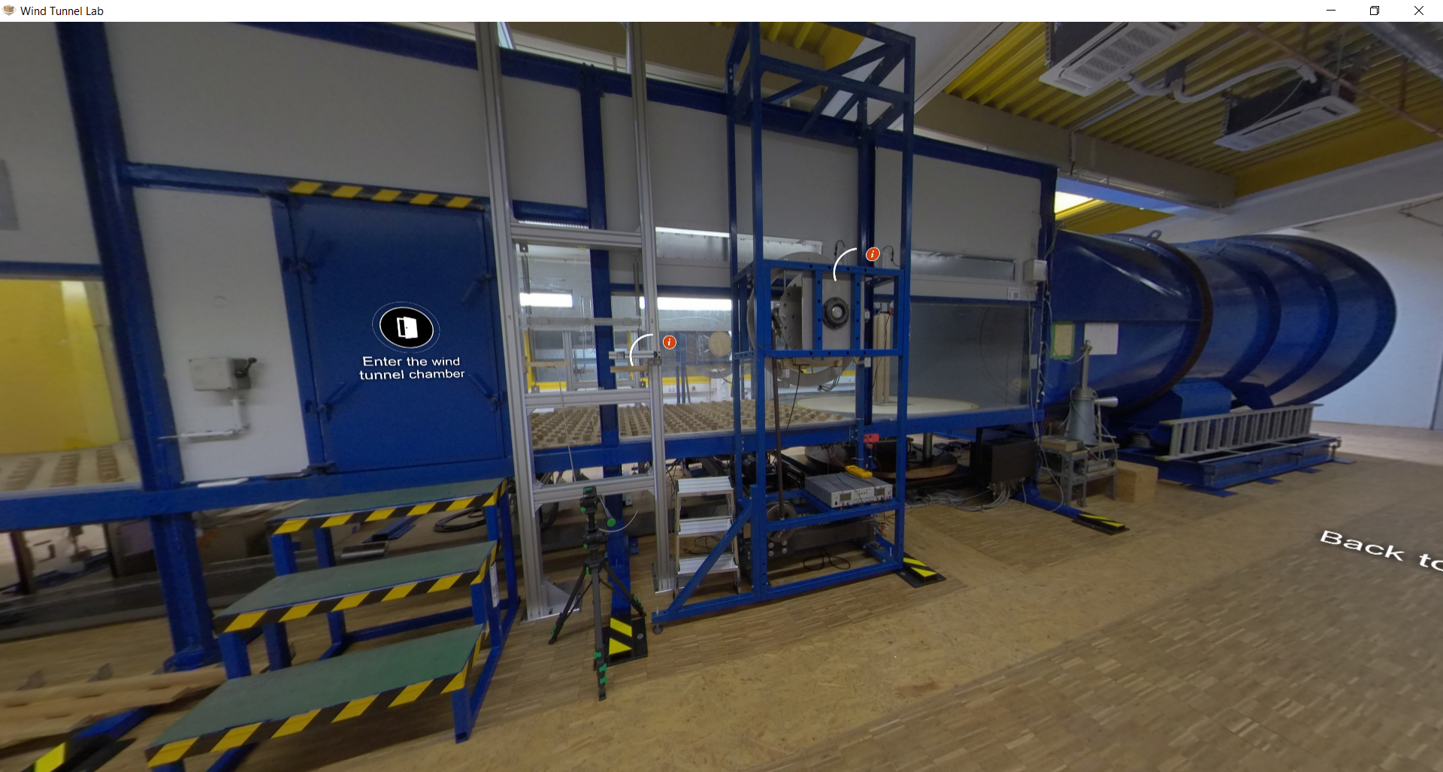

|  |  |  |
| --- | --- | --- |
| Nr | Hotspot (see red arrow) | Script |
| 1 | Hotspot: “See inside: Cantilever cylinder model (Grouped cylinders experiments)” | Hyperlink to a 360° Scene: WTInside_Cantilever1  With Title:  “See inside: Cantilever cylinder model (Grouped cylinders experiments)” |
| 2 | Hotspot: “See inside: Horizontal model (Free-Vibration and Forced Vibration experiments)” | Hyperlink to a 360° Scene: WTInside_HorizontalCyl  With Title:  “See inside: Horizontal model (Free-Vibration and Forced Vibration experiments)” |
| 3 | Hotspot: Free-Vibration Test Rig | Slide pictures/Album (with text):  Slide 1-Figure :    Slide-1 Text:  A free-vibration experiment can be done in this free-vibration test-rig, which is designed and created by Dr.-Ing. Francesca Lupi. The concept is to let the horizontal cylinder model to move freely due to wind with the associated damping and mass.  Slide 2-Figure:    Slide-2 Text:  To make sure the cylinder’s movement is solely due to the wind actions, not influenced by deflection of the spring, the test rig is designed so that all eight springs (other four are on the other side) are in tension. This means that maximum oscillation in the measurement will be acceptable as long as the oscillation occur when the spring is still in tension. (Source figure: Francesca Lupi, 2019)  Slide 3-Picture :    Slide-3 Text:  In the process of designing the test rig, mass of all the moving bodies must be considered, this includes the cylindrical model, traverse bar, and the accessories. Since the test-rig is designed when spring of tension, stiffness of the spring can be considered to estimate the damping of the system. Additional damper may be added, to observe ranges of frequencies.  Slide 4-Figure :    Slide-4 Text:  In this Free-Vibration test rig, the measurement will focus on the oscillation of the cylinder with the given wind flow. The oscillation is measured by laser measurement. Four laser sensors are placed on the lower-middle part of the test rig, both on left and right. The process of designing test-rig is very important, where the first estimation of highest lock-in amplitude due to Vortex Induced Vibration, should be estimated properly. This is critical so that the distance coverage of the laser sensor is sufficient to observe the estimated range of amplitudes.  How the slide Figure is displayed: |
| 4 | Hotspot: Traverse bar | Figure+Label:  Figure    Label:  “Traverse bar” |
| 5 | Hotspot: Tensioned spring | Slide pictures/Album (with text):  Slide-1 Figure:    Slide-1 Text:  The specification of tensioned spring is determined in the process of designing the test rig. Most important parameters that determine the choice of springs are spring elongation range, mass of the spring and forces of the spring.  Slide-2 Figure:    Slide-2 Text:  One of the spring that is selected to be used in this test-rig is tensioned spring from Gutekunst Federn, RZ-162U-23I. Please note that this is not the only spring that can be used for the test rig. A sophisticated design concept of the test rig allows the researcher to select the spring based on the given model and its natural frequency. In this virtual tour, the spring RZ-162U-23I will be used as an example.  Slide-3 File (is this possible?):  springs_rz-162u-23i.pdf  Slide-3 Label:  „Data sheet tensioned spring: RZ-162U-23I”  Slide-4 File:  force springs_rz-162u-23i.pdf  Slide-4 Label:  “Force displacement diagram of the spring: RZ-162U-23I” |
| 6 | Hotspot: Laser sensor | Slide pictures/Album (with text):  Figure-1:    Label-1:  “Laser sensor”. For more information regarding the laser sensor, go back to Control Room to check the type of sensors available.  Figure-2:    Label-2:  “Reflective surface” |
| 7 | Delete the Hotspot: “Feel the wind tunnel!” | Delete the hotspot.  Because feel the wind tunnel video is updated and moved to Scene WT_Corner1 |
| 8 | Hotspot: Force balance for the cantilever cylinder model | Slide pictures/Album (with text):  Slide-1 Figure:    Slide-1 Text:  The force-balance is installed here at the base of cantilever model, where the model is fixed. For example of the grouped cylinder experiments with cantilever model, the force balance used is K6D40 from supplier ME-Meßsysteme. The sampling rate in the scope of grouped cylinders experiment is 2000 Hz. For further details, see information about the sensors in the control room.  Slide-2 Figure:    Slide-2 Text:  The force balance is connected to the data acquisition system which will be further connected to the monitoring system in the control room of wind tunnel. |
| 9 | Hotspot: Snap-back test | Slide pictures/Album (with text):  Slide-1 Figure:    Slide-1 Text:  One of the most important steps before conducting an experiment in wind tunnel, is to obtain the information of structural properties. Structural damping is the key parameter to understand how susceptible is the structure to an aeroelastic phenomenon, such as Vortex-Induced Vibration. Snap-back test can be done to obtain the structural damping. (Source Figure: “Logarithmic decrement” by “Vietnamgeometer” through Wikipedia is licensed under CC BY-SA 4.0.)  Slide-2 Figure:    Slide-2 Text  The concept of snap-back test is to give the model a static load, and then release the given load so that the structure will freely vibrate in still air. The structure will oscillate, and the oscillation will decay depending on the structural damping of the model. Note that the structural damping includes the existence of still air.  Slide-3 Figure:    Slide-3 Text:  For example, for the case of cantilever model, a weighing mass is used to give a static load to the model. This is done by connecting the model with a rope and a weighing mass. Then the mass is released by cutting the rope, so that the cantilever model will freely vibrate. |
| 10 | Hotspot: General information of Forced-Vibration Test Rig | Slide pictures/Album (with text):  Slide-1 Figure:    Slide-1 Text:  The forced vibration test is one of the testing approaches where the aeroelastic properties of the test structure can be determined. It is important as it refers to the aeroelastic stability of the test structure under phenomenon such as galloping and Vortex-Induced Vibration (Lupi et al., 2018). The concept of forced vibration test generally utilizes a propulsion unit which drives the model harmonically. Due to the greater mechanical effort in this type of test, influence of turbulence in the wind tunnel can be minimized. Therefore, pure sinusoidal oscillation can be better realized. (Source Figure: Neuhaus, 2009)  Slide-2 Figure:    Slide-2 Text:  The test rig of the forced vibration in the WISt Wind Tunnel was developed by Neuhaus (2009, 2010). The propulsion unit of the test rig will move the horizontal model, where it oscillates harmonically at given amplitude and frequency. The model can move in three degree of freedom: horizontal (surge), vertical (heave), inclined and rotation (pitch). With the given frequency, the model oscillates, and its oscillation can be measured by laser sensors. At the same time, the vertical, horizontal forces and torsional moment are measured by force balance that are placed at the two ends of horizontal model. In this way, measurement of the force and oscillation of the model can be done simultaneously. (Source Figure: Neuhaus, 2009)  Slide-3 Figure:    Slide-3 Text:  To give summary on the mechanism of the forced vibration test rig, following passages are presented. The propulsion unit (motorized equipment) drives the horizontal shaft that extends vertically to the connecting rod through the steel disk in the lower side. The connection between the vertical connecting rod and the steel disk is eccentric. The eccentricity can be manually adjusted to select the desired oscillation amplitude. The desired frequency can be adjusted through the imposed rotation speed, where the propulsion unit rotates the steel disk and mechanically will set a vertical movement of the connecting rods. Then, the connecting rod will rotate the aluminum disk limited to a small range of rotation angle. (Continued to the next slide)  Slide-4 Figure:    Slide-4 Text:  The previously mentioned aluminum disk is then connected to a rectangular steel plate, which is connected rigidly to the external test rig frame. To achieve the pure vertical movement, the aluminum disk is connected to a crosspiece which can only move vertically and mechanically converts the rotational movement of aluminum disk to a vertical movement of the crosspiece. The crosspiece moves vertically along the guiding rods. This is important to evaluate a pure harmonic oscillation in vertical direction of the horizontal model, for the case of Vortex-Induced Vibration. (Source Figure: Adapted from Neuhaus, 2010, taken from Lupi et al., 2018)  Slide-5 Figure:    Slide-5 Text:  The maximum oscillation amplitude in this forced vibration test rig is 7.5 cm. Besides the movement in vertical direction (z), this test rig also can allow the movement to be purely rotational (α) or to be purely translational in horizontal (y) direction. The maximum frequency of oscillation is 7.25 Hz. Regarding the measurement of oscillation by laser sensors, the sampling rate is 2000 Hz. Further details about the forced vibration test setup are available in Neuhaus (2009, 2010) and Sarkic et al. (2012, 2015). (Source Figure: Neuhaus, 2009)  Slide-6 Text:  References:  [1] F. Lupi, H.J. Niemann, R. Höffer. 2018. Aerodynamic damping model in vortex-induced vibrations for wind engineering applications. Journal of Wind Engineering and Industrial Aerodynamics 174, pages 281-295.  [2] C. Neuhaus. 2009. Identification of 18 flutter derivatives by forced-vibration tests – a  new experimental rig. In: Proceedings of the 5th European African Conference on  Wind Engineering, Florence (Italy).  [3] C. Neuhaus. 2010. Zur Identifikation selbserregter aeroelastischer Kräfte im Zeitbereich. Dissertation. Bergischen Universität Wuppertal (in German).  [4] A. Sarkic, R. Fisch, R. Höffer, K.U. Bletzinger. 2012. Bridge flutter derivatives based on computed, validated pressure fields. Journal of Wind Engineering and Industrial Aerodynamics 104–106, pages 141–151.  [5] A. Sarkic, R. Höffer, B. Stanko. 2015. Numerical simulations and experimental validations of force coefficients and flutter derivatives of a bridge deck. Journal of Wind Engineering and Industrial Aerodynamics 144, pages 172–182. |
| 11 | Hotspot: Forced Vibration Test Rig - Propulsion unit | Figure+Text/Label:  Figure:    Label:  Propulsion Unit |
| 12 | Delete the two hotspot below | Delete the two hotspot because the related components have been explained above. |